Coord Science Semester 1

1. Google, look at order, self explanatory
2. 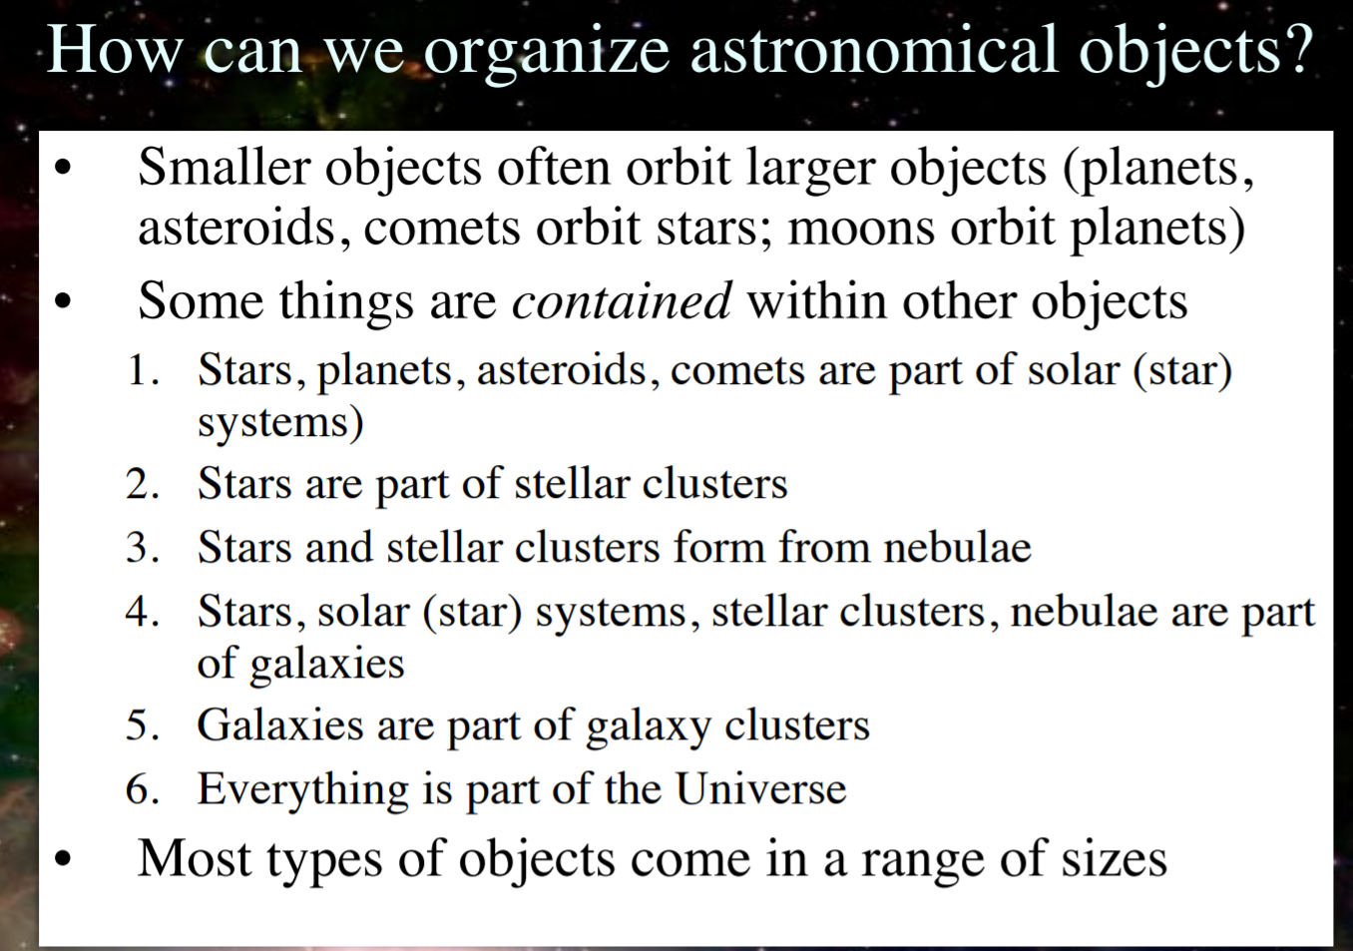

**2)** Look at the illustration above.

**3)** Hint: A light-year is a unit of distance, not time.

A *light-year* is how astronomers measure distance in space. It’s defined by how far a beam of light travels in one year – a distance of six trillion miles. Think of it as the bigger, badder cousin of the inch, the mile, the kilometer, and the furlong. If you like to keep up with what’s going on in astronomy, it’s worth spending a little bit of time understanding what the deal is with this funny unit of measurement.

**4)**

For most space objects, we use **light-years** to describe their distance. A light-year is the distance light travels in one Earth year. One light-year is about 6 trillion miles (9 trillion km). That is a 6 with 12 zeros behind it!

**Looking Back in Time**

When we use powerful telescopes to look at distant objects in space, we are actually looking back in time. How can this be?

Light travels at a speed of 186,000 miles (or 300,000 km) per second. This seems really fast, but objects in space are so far away that it takes a lot of time for their light to reach us. The farther an object is, the farther in the past we see it.

Our [**Sun**](https://spaceplace.nasa.gov/sun-age) is the closest star to us. It is about 93 million miles away. So, the Sun's light takes about 8.3 minutes to reach us. This means that we always see the Sun as it was about 8.3 minutes ago.

The next closest star to us is about 4.3 light-years away. So, when we see this star today, we’re actually seeing it as it was 4.3 years ago. All of the other stars we can see with our eyes are farther, some even thousands of light-years away.

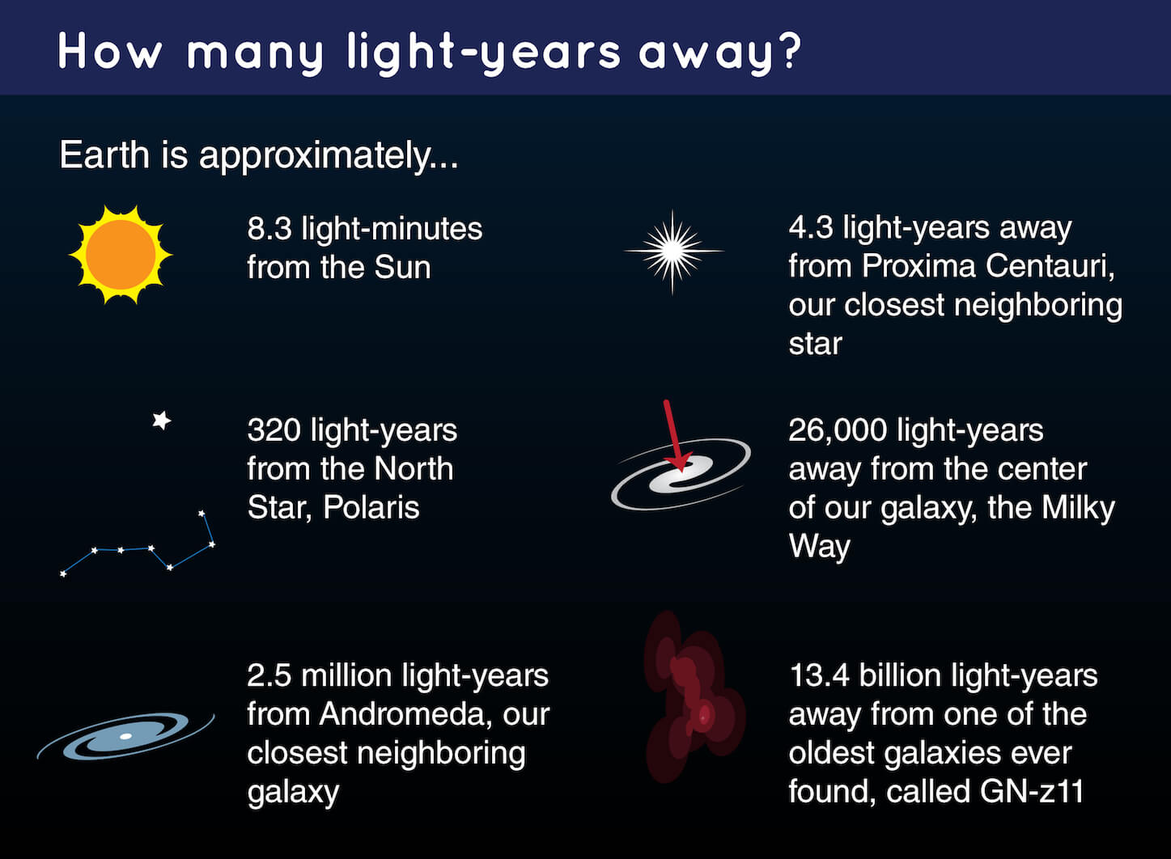

Stars are found in large groups called [**galaxies**](https://spaceplace.nasa.gov/galaxy). A galaxy can have millions or billions of stars. The nearest large galaxy to us, Andromeda, is 2.5 million light-years away. So, we see Andromeda as it was 2.5 million years in the past. The universe is filled with billions of galaxies, all farther away than this. Some of these galaxies are much farther away.

**5)**

## Electromagnetic Radiation Penetration

Electromagnetic waves readily penetrate the atmosphere. Even the less energetic radio waves from outer space reach the surface of the earth. Electromagnetic radiation with shorter wavelengths penetrates materials most effectively. X-rays have very short wavelengths, so they can penetrate the soft tissues of the human body. Gamma rays, which have the shortest wavelengths of all electromagnetic radiation, have even greater penetrating power. It takes “several centimeters of lead or more than a meter of concrete” to stop them, according to the Duke University Department of Chemistry.

**6)**

|  |  |  |  |  |  |  |  |  |  |
| --- | --- | --- | --- | --- | --- | --- | --- | --- | --- |
| |  | | --- | |  | | The Electromagnetic Spectrum | | A quick review: The Sun is a star - a furnace in which hydrogen nuclei undergo fusion to produce helium (and much rarer and heavier elements), and during which, about 0.3% of their mass is converted to energy. | | The Sun emits energy in two major forms:  1. The solid material is called plasma (which is actually the composition of the sun), a mixture of ions, electrons, and neutral atoms, which is emitted along perturbations in the Sun's magnetic field, and causes solar flares and coronal mass ejections (CMEs). 2. Radiation (heat energy) has no mass and travels at the speed of light. Radiation is one of three ways in which heat is transferred:  |  |  | | --- | --- | |  | * ***Conduction:*** Heat (energy is transferred from warmer to cooler materials by direct molecular contact (e.g. hand burned by a pot handle). * ***Convection:*** Heat moves with a substance from one place to another. * ***Radiation:*** Heat moves from source through a material or vacuum. | | | |  |  | | --- | --- | | https://ucmp.berkeley.edu/education/dynamic/session5/images_sess5/spectrum.gif | Radiation is emitted throughout the **electromagnetic spectrum** at the speed of light, whether or not we can see it. The shorter the wavelength, the higher the energy. Infrared is the region of the **electromagnetic spectrum** that extends from the visible region to about one millimeter (in wavelength). Infrared **waves** include thermal **radiation**. For example, burning charcoal may not give off light, but it does emit infrared **radiation** which is felt as **heat**.  In the image on the left, The electromagnetic spectrum illustrates the wavelengths and names of various types of radiation. image courtesy www.nasa.govSolar radiation is composed of:  * 40% at wavelengths of infrared (IR) or longer * 50% at visible wavelengths * 10% at wavelengths of ultraviolet (UV) or shorter (think: skin penetration) | | |

**7)**

**Science of Summer: What Causes Sunburns?**

By [Adam Hadhazy](https://www.livescience.com/author/adam-hadhazy) July 09, 2013 [Health](https://www.livescience.com/health)

Summer means lots of out-of-doors time. Whether at beaches, barbeques, hanging out in the park or at the pool, most people catch more sun rays this season than other times of the year. In the process, some will get a suntan while others, unfortunately, will experience the painful redness, peeling and blistering that can occur with a bad sunburn.

So what is [the skin](https://www.livescience.com/27115-skin-facts-diseases-conditions.html) up to when it starts soaking up sunlight and changing its hue [this summer](https://www.livescience.com/24592-summer.html)? Essentially, a suntan results from the body's natural defense mechanism kicking in against damaging ultraviolet sun rays. When the defenses are overwhelmed, a toxic reaction occurs, resulting in [sunburn](https://www.livescience.com/36539-sunburn-rna-skin.html).

The defense mechanism is a pigment called melanin, which is produced by cells in our skin called melanocytes. Melanin absorbs ultraviolet light and dissipates it as heat.

**DNA buster**

Invisible ultraviolet light carries more energy than the light visible to humans, and this energy packs a tiny punch.

When a UV photon strikes the skin, it can damage the DNA in the body's cells. It does this by breaking the orderly bonds between the four nucleotides, adenosine, thymine and guanine. So-called thymine dimers form, when two thymine nucleotides bind together, throwing the whole shape of [the DNA molecule](https://www.livescience.com/37247-dna.html) out of whack.

The cell with the messed-up DNA usually then commits suicide, a process called apoptosis.

**8)**

# Tour of the Electromagnetic Spectrum

# Visible Light

[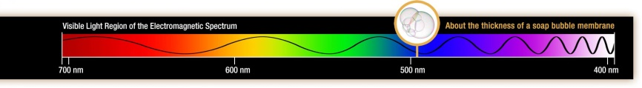](https://science.nasa.gov/files/science-red/s3fs-public/thumbnails/image/visible-wave.jpg)

## What is the visible light spectrum?

The visible light spectrum is the segment of the electromagnetic spectrum that the human eye can view. More simply, this range of wavelengths is called visible light. Typically, the human eye can detect wavelengths from 380 to 700 nanometers.

#### WAVELENGTHS OF VISIBLE LIGHT

All electromagnetic radiation is light, but we can only see a small portion of this radiation—the portion we call visible light. Cone-shaped cells in our eyes act as receivers tuned to the wavelengths in this narrow band of the spectrum. Other portions of the spectrum have wavelengths too large or too small and energetic for the biological limitations of our perception.

As the full spectrum of visible light travels through a prism, the wavelengths separate into the colors of the rainbow because each color is a different wavelength. Violet has the shortest wavelength, at around 380 nanometers, and red has the longest wavelength, at around 700 nanometers.

[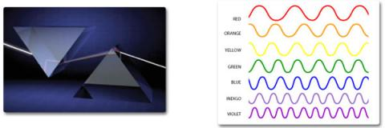](https://science.nasa.gov/files/science-red/s3fs-public/thumbnails/image/visible-1-2.jpg)

***(Left)****Isaac Newton's experiment in 1665 showed that a prism bends visible light andthat each color refracts at a slightly different angle depending on the wavelength of the color.Credit: Troy Benesch.****(Right)****Each color in a rainbow corresponds to a different wavelength of electromagnetic spectrum.*

**9)**

|  |
| --- |
| [The Electromagnetic Spectrum header  graphic.](https://www.univie.ac.at/geographie/fachdidaktik/FD/site/external_htmls/imagers.gsfc.nasa.gov/ems/ems.html) |
| Electromagnetic Waves have different wavelengths. spectrum vary in size from very long radio waves the size of buildings, to very short gamma-rays smaller than the size of the nucleus of an atom.  A chart showing the electromagnetic spectrum. [D of electromagnetic spectrum chart](https://www.univie.ac.at/geographie/fachdidaktik/FD/site/external_htmls/imagers.gsfc.nasa.gov/ems/emschart.html)  Did you know that electromagnetic waves can not only be described by their wavelength, but also by their energy and frequency? All three of these things are [related to each other mathematically](https://www.univie.ac.at/geographie/fachdidaktik/FD/site/external_htmls/imagers.gsfc.nasa.gov/ems/waves4.html). This means that it is correct to talk about the energy of an X-ray or the wavelength of a microwave or the frequency of a radio wave.  The electromagnetic spectrum includes, from longest wavelength to shortest: radio waves, microwaves, infrared, optical, ultraviolet, X-rays, and gamma-rays. |

**10)**

Why Does An Ambulance (Or Police) Siren Sound Different As It Passes By?

Imagine driving home along a road that has a surprisingly small amount of traffic. Suddenly, you hear the distant wail of a siren. Before you even turn your head to see, your mind has already registered that an ambulance is approaching your position from behind. The siren sounds louder and more shrill as the ambulance approaches your car, but then changes its pitch as soon as the ambulance overtakes you, almost like an opera singer can change the shrillness of her voice. You can’t help but notice the unique, shifting sound of the siren.

Siren designers must be pretty clever to come up with a siren that changes its pitch automatically!

If this thought has ever crossed your mind, then you may be in for a surprise! In truth, cutting-edge sirens aren’t making you hear different pitches of the siren as it moves; instead, its an extremely simple physical phenomenon.

### The Doppler Effect

First, listen to the changing pitch of the siren from a fire engine (fire truck) in the video below:

Notice how the sound of the siren changes as the truck passes by the camera? That’s the strange occurrence that we want to talk about.

This difference in the sound of the siren (or the horn of a car or a train) is due to a scientific phenomenon called the **Doppler Effect**. Like many other phenomena, the Doppler effect is named after a scientist, Christian Doppler, who is credited with its discovery. Our world is replete with events and daily-life experiences that are associated with Doppler effect. Let’s see a bit more about what the Doppler effect actually is.

The Doppler effect is observed when the source of a particular set of waves is moving with respect to the observer. Suppose you are standing on the sidewalk, waiting to cross the street. On the far left side of your position, you see an ambulance racing in your direction. In this case, the siren on the ambulance is the source of the waves (sound waves, in this case) and you are the observer.

**11)**

A star's energy comes from the combining of light [elements](https://helios.gsfc.nasa.gov/gloss_ef.html#element) into heavier elements in a process known as **fusion**, or "nuclear burning". It is generally believed that most of the elements in the universe heavier than helium are created, or synthesized, in stars when lighter [nuclei](https://helios.gsfc.nasa.gov/gloss_mn.html#nucleus) fuse to make heavier nuclei. The process is called **nucleosynthesis**.

Nucleosynthesis requires a high-speed collision, which can only be achieved with very high temperature. The minimum temperature required for the fusion of hydrogen is 5 million degrees. Elements with more protons in their nuclei require still higher temperatures. For instance, fusing carbon requires a temperature of about one billion degrees! Most of the heavy elements, from oxygen up through iron, are thought to be produced in stars that contain at least ten times as much matter as our Sun.

Our Sun is currently burning, or fusing, hydrogen to helium. This is the process that occurs during most of a star's lifetime. After the hydrogen in the star's core is exhausted, the star can burn helium to form progressively heavier elements, carbon and oxygen and so on, until iron and nickel are formed. Up to this point the process releases energy. The formation of elements heavier than iron and nickel requires the input of energy. **Supernova** explosions result when the cores of massive stars have exhausted their fuel supplies and burned everything into iron and nickel. The nuclei with mass heavier than nickel are thought to be formed during these explosions.

**12)**

# How do elements heavier than iron form?

All of the elements on earth heavier than helium were produced in stellar furnaces, the chemical elements up to the iron peak are produced in ordinary stellar nucleosynthesis.

Many elements heavier than iron are formed supernova explosions. The amount of energy released during a supernova explosion is so high that the freed energy and copious free neutrons streaming from the collapsing core result into massive fusion reactions, long past the formation of iron. Sure, this absorbs a lot of energy. Hence for elements heavier than iron, *nuclear fusion consumes energy* but there's plenty available once the explosion has begun or that the *nuclear fission releases it*. The creation of rarer elements (heavier than iron and nickel), were a result of the type II supernova event’s last few seconds. The synthesis is endothermic as are created from the energy produced during the supernova explosion.

The abundances of elements between Mg (Z=12) and Ni (Z=28). is due to the supernova nucleosynthesis within the exploding stars by fusion of C and O.

Some of those elements are created from the absorption of multiple neutrons in the period of a few seconds during the explosion. The elements formed in supernovas include the heaviest elements known, such as the long-lived elements uranium and thorium.

**13)**

## What the Theory Explains

As it relates to our own solar system, the nebular theory explains three observable facts. The first is that the planets all rotate in the same direction. The second is that they all orbit within 6 degrees of a common plane. The third is that all the terrestrial planets, which are those within the orbit of the Asteroid Belt, are rocky, while those outside it are gaseous. The theory also explains the existence of the Kuiper Belt -- a region on the fringes of the solar system with a high concentration of comets.

## A Star Is Born

According to the nebular theory, a solar system begins when an interstellar cloud, containing approximately 75 percent hydrogen, 25 percent helium and traces of other elements, begins to form areas of higher concentration, or clumps. As the clumps grow, gravitational forces increase and get converted to the kinetic energy of the increasingly fast-moving particles, which collide with one another and generate heat. Eventually one clump dominates, and when its temperature reaches 10 million degrees Kelvin (18 million degrees Fahrenheit), nuclear fission begins. The outward pressure created by the fission reactions prevents further collapse, and the clump of burning hydrogen gas stabilizes and becomes a star.

## Seeds of Planets

As a proto-star grows in size, the gases in the nebula from which it is born form a disk and spiral more and more quickly around its center. Eventually, elements on the fringe of the disk begin to form into globules with compositions that depend on their distance from the center. At smaller distances, where temperatures are higher, they are formed of heavy elements, while at greater distances they are formed of ices of water, methane and ammonia. These globules collide with each other and stick together to form larger, spherical bodies in a process called accretion. The larger bodies, with diameters of a few kilometers, are called planetesimals.

## Planets and Comets

Once planetesimals form, collisions continue, but they tend to be destructive, and only the largest planetesimals survive. These continue to grow by assimilating surrounding material, including smaller planetesimals, to become planets. The composition of planets closer to the center of the system differs from that of those farther away. The planets within a critical distance, where temperatures are warmer, are rocky, while those beyond the critical distance have solid cores and thick, gaseous atmospheres. At the fringes of the solar system, where gravitational forces are weak, planetesimals never coalesce into planets. These icy bodies sometimes wander in eccentric orbits, and when they get close to the sun, we know them as comets.

__

14

.

# Main Sequence Stars: Definition & Life Cycle

This Hubble Space Telescope image shows Sirius A, the brightest star in our nighttime sky, along with its faint, tiny stellar companion, Sirius B. Astronomers overexposed the image of Sirius A so that the dim Sirius B (tiny dot at lower left) could be seen. The cross-shaped diffraction spikes and concentric rings around Sirius A, and the small ring around Sirius B, are artifacts produced within the telescope's imaging system. The two stars revolve around each other every 50 years. Sirius A, only 8.6 light-years from Earth, is the fifth closest star system known.

(Image: © NASA, H.E. Bond and E. Nelan (Space Telescope Science Institute, Baltimore, Md.); M. Barstow and M. Burleigh (University of Leicester, U.K.); and J.B. Holberg (University of Arizona))

Main sequence stars fuse hydrogen atoms to form helium atoms in their cores. About 90 percent of the stars in the universe, including the sun, are main sequence stars. These stars can range from about a tenth of the mass of the sun to up to 200 times as massive.

Stars start their lives as clouds of dust and gas. Gravity draws these clouds together. A small [protostar](https://www.space.com/18774-baby-protostar-growing.html) forms, powered by the collapsing material. Protostars often form in densely packed clouds of gas and can be challenging to detect.

"Nature doesn't form stars in isolation," Mark Morris, of the University of California at Los Angeles (UCLS), said in a [statement](http://www.nasa.gov/mission_pages/SOFIA/status_update_10-46F.html). "It forms them in clusters, out of natal clouds that collapse under their own gravity."

Smaller bodies — with less than 0.08 the sun's mass — cannot reach the stage of nuclear fusion at their core. Instead, they become [brown dwarfs](https://www.space.com/23798-brown-dwarfs.html), stars that never ignite. But if the body has sufficient mass, the collapsing gas and dust burns hotter, eventually reaching temperatures sufficient to fuse hydrogen into helium. The star turns on and becomes a main sequence star, powered by hydrogen [fusion](https://www.livescience.com/23394-fusion.html). Fusion produces an outward pressure that balances with the inward pressure caused by gravity, stabilizing the star.

How long a main sequence star lives depends on how massive it is. A higher-mass star may have more material, but it burns through it faster due to higher core temperatures caused by greater gravitational forces. While the sun will spend about 10 billion years on the main sequence, a star 10 times as massive will stick around for only 20 million years. A [red dwarf](http://hubblesite.org/newscenter/archive/releases/2011/02/full), which is half as massive as the sun, can last 80 to 100 billion years, which is far longer than the universe's age of [13.8 billion years](https://www.space.com/24054-how-old-is-the-universe.html). (This long lifetime is one reason red dwarfs are considered to be [good sources](https://www.space.com/14659-red-dwarf-stars-planets-habitable-zones.html) for [planets hosting life](https://www.space.com/15433-alien-life-red-dwarfs-habitable-planets.html), because they are stable for such a long time.)

## Bright shining star

More than 2,000 years ago, the Greek astronomer Hipparchus was the first to make [a catalog of stars according to their brightness](https://www.space.com/21640-star-luminosity-and-magnitude.html), according to Dave Rothstein, who participated in Cornell University's "Ask An Astronomer" website in 2003.

"Basically, he looked at the stars in the sky and classified them by how bright they appear — the brightest stars were 'magnitude 1,' the next brightest were 'magnitude 2,' etc., down to 'magnitude 6,' which were the faintest stars he could see," Rothstein wrote.

Modern instruments have improved measurements of brightness, making them more precise.

In the early 20th century, astronomers realized that the mass of a star is related to its [luminosity](https://www.space.com/21640-star-luminosity-and-magnitude.html), or how much light it produces. These are both related to the stellar temperature. Stars 10 times as massive as the sun shine more than a thousand times as much.

The mass and luminosity of a star also relate to its color. More massive stars are hotter and bluer, while less massive stars are cooler and have a reddish appearance. The sun falls in between the spectrum, given it a more yellowish appearance.

"The surface temperature of a star determines the color of light it emits," according to the worldwide [Las Cumbres Observatory](https://lco.global/spacebook/magnitude-and-color/). "Blue stars are hotter than yellow stars, which are hotter than red stars."

This understanding lead to the creation of a plot known as the Hertzsprung-Russell (H-R) diagram, a graph of stars based on their brightness and color (which in turn shows their temperature). Most stars lie on a line known as the "main sequence," which runs from the top left (where hot stars are brighter) to the bottom right (where cool stars tend to be dimmer). [Video: [Constructing the Hertzsprung-Russell Diagram](http://hubblesite.org/newscenter/archive/releases/2010/28/video/d) (Hubble site)]

## When the stars go out

Eventually, a main sequence star burns through the hydrogen in its core, reaching the end of its life cycle. At this point, it leaves the main sequence.

Stars smaller than a quarter the mass of the sun collapse directly into [white dwarfs](https://www.space.com/19954-alien-life-planets-white-dwarfs.html). White dwarfs no longer burn fusion at their center, but they still radiate heat. Eventually, white dwarfs should cool into [black dwarfs](https://www.space.com/23799-black-dwarfs.html), but black dwarfs are only theoretical; the universe is not old enough for the first white dwarfs to sufficiently cool and make the transition.

Larger stars find their outer layers collapsing inward until temperatures are hot enough to fuse helium into carbon. Then the pressure of fusion provides an outward thrust that expands the star several times larger than its original size, forming a [red giant](https://www.space.com/22471-red-giant-stars.html). The new star is far dimmer than it was as a main sequence star. Eventually, the sun will form a red giant, but don't worry — it won't happen for [a while yet](https://www.youtube.com/user/VideoFromSpace).

Advertisement

"Some five billion years from now, after the sun has become a red giant and burned the Earth to a cinder, it will eject its own beautiful nebula and then fade away as a white dwarf star," Howard Bond, of Space Telescope Science Institute in Maryland, said in a [statement](http://hubblesite.org/newscenter/archive/releases/1997/38/text/).

If the original star had up to 10 times the mass of the sun, it burns through its material within 100 million years and collapses into a super-dense white dwarf. More massive stars explode in a [violent supernova death](https://www.space.com/6638-supernova.html), spewing the heavier elements formed in their core across the galaxy. The remaining core can form a [neutron star](https://www.space.com/22180-neutron-stars.html), a compact object that can come in a [variety of forms](http://chandra.harvard.edu/xray_sources/neutron_stars.html).

The long lifetime of red dwarfs means that even those formed shortly after the Big Bang still exist today. Eventually, however, these low-mass bodies will burn through their hydrogen. They will grow dimmer and cooler, and eventually the lights will go out.

**15**)

__

A star's life cycle is determined by its mass. The larger its mass, the shorter its life cycle. A star's mass is determined by the amount of [matter](https://imagine.gsfc.nasa.gov/resources/dict_jp.html#matter) that is available in its [nebula](https://imagine.gsfc.nasa.gov/resources/dict_jp.html#nebula), the giant cloud of gas and dust from which it was born. Over time, the [hydrogen](https://imagine.gsfc.nasa.gov/resources/dict_ei.html#hydrogen) gas in the nebula is pulled together by [gravity](https://imagine.gsfc.nasa.gov/resources/dict_ei.html#gravity) and it begins to spin. As the gas spins faster, it heats up and becomes as a protostar. Eventually the temperature reaches 15,000,000 degrees and [nuclear fusion](https://imagine.gsfc.nasa.gov/resources/dict_jp.html#nuclear_fusion) occurs in the cloud's core. The cloud begins to glow brightly, contracts a little, and becomes stable. It is now a main sequence star and will remain in this stage, shining for millions to billions of years to come. This is the stage our Sun is at right now.

**16)**

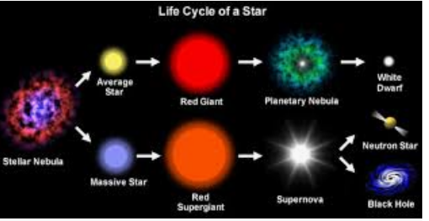

**__**

**17)**

Small Stars- The Life of a Star of about one Solar Mass.

Small stars have a mass up to one and a half times that of the Sun.

Stage 1- Stars are born in a region of high density ***Nebula***, and condenses into a huge globule of gas and dust and contracts under its own gravity.Stage 2 - A region of condensing matter will begin to heat up and start to glow forming ***Protostars.***If a protostar contains enough matter the central temperature reaches 15 million degrees centigrade.Stage 3 - At this temperature, nuclear reactions in which hydrogen fuses to form helium can start.Stage 4 - The star begins to release energy, stopping it from contracting even more and causes it to shine. It is now a M***ain Sequence Star.***Stage 5 - A star of one solar mass remains in main sequence for about 10 billion years, until all of the hydrogen has fused to form helium.Stage 6 - The helium core now starts to contract further and reactions begin to occur in a shell around the core.Stage 7 - The core is hot enough for the helium to fuse to form carbon. The outer layers begin to expand, cool and shine less brightly. The expanding star is now called a ***Red Giant.***Stage 8 - The helium core runs out, and the outer layers drift of away from the core as a gaseous shell, this gas that surrounds the core is called a ***Planetary Nebula***.Stage 9 - The remaining core (thats 80% of the original star) is now in its final stages. The core becomes a W***hite Dwarf*** the star eventually cools and dims. When it stops shining, the now dead star is called a ***Black Dwarf***.

**___18)**

Because of Keplar's laws we can measure the mass of binary stars systems pretty actually. In addition we can also measure how bright the star is, its luminocity. All of the energy that a star releases is from it changing matter into energy (like in Einstein's equation E=mc2E=mc2). The brightness of the star is proportional to the rate at which it changes matter into energy.

**19)**

(SEE Question 20)

**___20)**

The **Big Bang** is a [scientific](https://simple.wikipedia.org/wiki/Science) [theory](https://simple.wikipedia.org/wiki/Theory) about how the [universe](https://simple.wikipedia.org/wiki/Universe) started, and then made the [stars](https://simple.wikipedia.org/wiki/Star) and [galaxies](https://simple.wikipedia.org/wiki/Galaxy) we see today. The Big Bang is the name that scientists use for the most common theory of the [universe](https://simple.wikipedia.org/wiki/Universe),[[2]](https://simple.wikipedia.org/wiki/Big_Bang#cite_note-NYT-20170220-2)[[3]](https://simple.wikipedia.org/wiki/Big_Bang#cite_note-3)[[4]](https://simple.wikipedia.org/wiki/Big_Bang#cite_note-4) from the very early stages to the present day.[[5]](https://simple.wikipedia.org/wiki/Big_Bang#cite_note-5)[[6]](https://simple.wikipedia.org/wiki/Big_Bang#cite_note-6)[[7]](https://simple.wikipedia.org/wiki/Big_Bang#cite_note-7)

The universe began as a very [hot](https://simple.wikipedia.org/wiki/Heat), [small](https://simple.wikipedia.org/wiki/Size), and dense superforce (the mix of the four [fundamental forces](https://simple.wikipedia.org/wiki/Fundamental_force)), with no stars, [atoms](https://simple.wikipedia.org/wiki/Atom), form, or structure (called a "[singularity](https://simple.wikipedia.org/wiki/Singularity)"). Then about 13.8 [billion](https://simple.wikipedia.org/wiki/Billion) years ago,[[1]](https://simple.wikipedia.org/wiki/Big_Bang#cite_note-NASA-1) [space](https://simple.wikipedia.org/wiki/Outer_space) expanded very quickly (thus the name "Big Bang"). This started the formation of atoms, which eventually led to the formation of stars and galaxies. It was [Georges Lemaître](https://simple.wikipedia.org/wiki/Georges_Lema%C3%AEtre) who first noted (in 1927) that an expanding universe could be traced back in time to an originating single point. The universe is still expanding today, and getting colder as well.

As a whole, the universe is growing and the [temperature](https://simple.wikipedia.org/wiki/Temperature) is falling as [time](https://simple.wikipedia.org/wiki/Time) passes. [Cosmology](https://simple.wikipedia.org/wiki/Cosmology) is the study of how the universe began and its development. [Scientists](https://simple.wikipedia.org/wiki/Scientist) who study cosmology have agreed that the Big Bang theory matches what they have observed so far.[[1]](https://simple.wikipedia.org/wiki/Big_Bang#cite_note-NASA-1)

**21)**

most galaxies are moving apart from one another

**Big Bang Theory - Evidence for the Theory**  
What are the major evidences which support the Big Bang theory?

* First of all, we are reasonably certain that the universe had a beginning.
* Second, galaxies appear to be moving away from us at speeds proportional to their distance. This is called "Hubble's Law," named after Edwin Hubble (1889-1953) who discovered this phenomenon in 1929. This observation supports the expansion of the universe and suggests that the universe was once compacted.

__

**22)**

Approximately 4.6 billion years ago, **the solar system** was a cloud of dust and gas known as a **solar nebula**. Gravity collapsed **the** material in on itself as it began to spin, **forming the sun** in **the** center of **the nebula**. With **the** rise of **the sun**, **the** remaining material began to clump together. After the sun formed, a massive disk of material surrounded it for around 100 million years. That may sound like more than enough time for the planets to form, but in astronomical terms, it's an eye blink. As the newborn sun heated the disk, gas evaporated quickly, giving the newborn planets and moons only a short amount of time to scoop it up.

__

**23)**

# How Did the Solar System Form?

(Image: © NASA/JPL)

Approximately 4.5 billion years ago, gravity pulled a cloud of dust and gas together to form our solar system. While scientists aren't certain of the exact nature of the process, observations of young stellar systems combined with computer simulations have allowed them to develop three models of what could have happened so many years ago.

## Birth of the sun

A massive concentration of interstellar gas and dust created a molecular cloud that would form the sun's birthplace. Cold temperatures caused the gas to clump together, growing steadily denser. The densest parts of the cloud began to collapse under its own gravity, forming a wealth of young stellar objects known as protostars. Gravity continued to collapse the material onto the infant object, creating a star and a disk of material from which the planets would form. When fusion kicked in, the star began to blast a stellar wind that helped clear out the debris and stopped it from falling inward.

Although gas and dust shroud young stars in visible wavelengths, infrared telescopes have probed many of the Milky Way Galaxy's clouds to reveal the natal environment of other stars. Scientists have applied what they've seen in other systems to our own star.

After the sun formed, a massive disk of material surrounded it for around 100 million years. That may sound like more than enough time for the planets to form, but in astronomical terms, it's an eye blink. As the newborn sun heated the disk, gas evaporated quickly, giving the newborn planets and moons only a short amount of time to scoop it up.

__

**24)**

**Terrestrial vs Jovian planets**

The planets in the solar system are divided into terrestrial and jovian planets. They are different in their position, composition and other features.

First of all, let us see what are the jovian and the terrestrial planets. Jupiter, Saturn, Uranus and Neptune are the jovian planets. Mercury, [Venus and Earth](http://www.differencebetween.net/science/difference-between-earth-and-venus/) are the terrestrial planets.

One of the main differences that can be seen between terrestrial and jovian planets, is their surfaces. While the terrestrial planets are made of solid surfaces, the jovian planets are made of gaseous surfaces.

Well, the jovian planets are less dense when compared to the terrestrial planets, because they are mainly composed of hydrogen gas. Moreover, the core of the jovian planets is more dense than the terrestrial [planets](http://www.differencebetween.net/science/difference-between-stars-and-planets/).

When talking of the distance from the sun, the terrestrial planets are closer to the sun and the jovian planets are farther. When considering the size, the jovian planets are much larger than the terrestrial planets. While the atmosphere of terrestrial planets is composed mainly of carbon dioxide and nitrogen gases, hydrogen and helium gases are found in abundance in the atmosphere of jovian planets.

**25)**

# Gas Giants: Facts About the Outer Planets

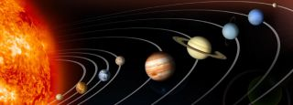

The planets of the solar system as depicted by a NASA computer illustration. Orbits and sizes are not shown to scale.

(Image: © NASA)

A gas giant is a large planet composed mostly of gases, such as hydrogen and helium, with a relatively small rocky core. The gas giants of our solar system are Jupiter, Saturn, Uranus and Neptune. These four large planets, also called jovian planets after Jupiter, reside in the outer part of the solar system past the orbits of Mars and the asteroid belt. Jupiter and Saturn are substantially larger than Uranus and Neptune, and each pair of planets has a somewhat different composition.

Although there are only four large planets in our solar system, astronomers have discovered thousands outside of it, particularly using NASA's Kepler Space Telescope. These exoplanets (as they are called) are being examined to learn more about how our solar system came to be.

## Basic facts

**Jupiter** is the largest planet in our solar system. It has a radius almost 11 times the size of Earth. It has 50 known moons and 17 waiting to be confirmed, [according to NASA](https://solarsystem.nasa.gov/planets/profile.cfm?object=jupiter). The planet is mostly made of hydrogen and helium surrounding a dense core of rocks and ice, with most of its bulk likely made up of liquid metallic hydrogen, which creates a huge magnetic field. Jupiter is visible with the naked eye and was known by the ancients. Its atmosphere consists mostly of hydrogen, helium, ammonia and methane. [[Related: Planet Jupiter: Facts About Its Size, Moons and Red Spot](https://www.space.com/7-jupiter-largest-planet-solar-system.html)]

**Saturn** is about nine times Earth's radius and is characterized by large rings; how they formed is unknown. It has 53 known moons and nine more awaiting confirmation, [according to NASA](https://solarsystem.nasa.gov/planets/profile.cfm?object=saturn). Like Jupiter, it is mostly made up of hydrogen and helium that surround a dense core and was also tracked by ancient cultures. Its atmosphere is similar to Jupiter's. [[Related: Planet Saturn: Facts About Saturn’s Rings, Moons & Size](https://www.space.com/48-saturn-the-solar-systems-major-ring-bearer.html)]

**Uranus** has a radius about four times that of Earth's. It is the only planet tilted on its side, and it also rotates backward relative to every planet but Venus, implying a huge collision disrupted it long ago. The planet has 27 moons, and its atmosphere is made up of hydrogen, helium and methane, [according to NASA](https://solarsystem.nasa.gov/planets/profile.cfm?object=uranus). It was discovered by William Herschel in 1781. [[Related: Planet Uranus: Facts About Its Name, Moons & Orbit](https://www.space.com/45-uranus-seventh-planet-in-earths-solar-system-was-first-discovered-planet.html)]

**Neptune** also has a radius about four times that of Earth's. Like Uranus, its atmosphere is mostly made up of hydrogen, helium and methane. It has 13 confirmed moons and an additional one awaiting confirmation, [according to NASA](https://solarsystem.nasa.gov/planets/profile.cfm?object=neptune). It was discovered by several people in 1846. [[Related: Planet Neptune: Facts About Its Orbit, Moons & Rings](https://www.space.com/41-neptune-the-other-blue-planet-in-our-solar-system.html)]

Super-Earths: Scientists have found a multitude of "super-Earths" (planets between the size of Earth and Neptune) in other solar systems. There are no known super-Earths in our own solar system, although some scientists speculate there may be a "Planet Nine" lurking in the outer reaches of our solar system. Scientists are studying this category of planets to learn whether super-Earths are more like small giant planets or big terrestrial planets.

Chemistry Matching

Atoms

_____26. Proton A. A negatively charged particle found outside the nucleus

_____27. Neutron B. Contains protons and neutrons in an atom

_____28. Electron C. A neutral particle found in the nucleus

_____29. Nucleus D. Contains electrons

_____30. Energy Level E. A positively charged particle found in the nucleus

Groups

_____31. Alkali Metals A.Non-reactive and colorless

_____32. Alkaline Earth Metals B.Contain elements that produce a magnetic field

_____33. Transition Metals C.Have 2 valence electrons

_____34. Halogens D.Explode when in contact with water

_____35. Noble Gases E. Very reactive and form salts

Bonding

_____36. Ion A. an atom with more or less neutrons

_____37. Isotope B. elements that naturally bond to themselves

_____38. ionic bond C. the attraction of appositive and a negative atom

_____39. covalent bond D. the amount of electrons an atom has lost or gained

_____40. Oxidation number E. an atom with more or less electrons

_____41. Diatomic element F. the sharing of electrons between atoms

ATOMS:

Electron: **A negatively charged particle found** circling or orbiting an atomic **nucleus**. An electron, like a proton is a **charged particle**, although opposite in sign, but unlike a proton, an electron has negligible atomic mass. Electrons contribute no atomic mass units to the total atomic weight of an atom.

The nucleus (center) of the **atom contains** the **protons** (positively charged) and the **neutrons** (no charge).

Neutron: neutral particle, composed of quarks, inside the nucleus of an atom

Electrons in an atom are contained in specific **energy levels** (1, 2, 3, and so on) that are different distances from the nucleus. ... Electrons seek the lowest **energy level** possible. The following electron-filling pattern indicates how the electrons fill into the **energy levels contain electrons**.

The nucleus (center) of the atom **contains** the protons (positively charged) and the neutrons (no charge).

GROUPS:

Alkali metals: explode under water

Alkaline Earth metals Group 2 Elements. Shiny, silvery white metals. They are also highly reactive, but slightly less than the alkali metals. They have **two valence electrons**, which they give up to form ions with a 2+ charge.

Transition metals: There are three noteworthy **elements** in the **transition metals** family. These **elements** are iron, cobalt, and nickel, and they are the only **elements** known to **produce** a **magnetic field**. The **Transition Metals** are: Scandium.

Chemically, sodium is **highly reactive** with the halogen family to **form** ionic **salts**. For example, sodium is commonly found combined with chloride to **form** NaCl, known to us as table **salt**. It has one electron in the outermost electron shell and thus wants to give up one electron to a **highly** electronegative element.

Neon is a **non**-**reactive** gas. It has **no color** and no smell, but when you send electricity through neon, it glows red. It is one of the noble or inert gases.

Chemically, sodium is **highly reactive** with the halogen family to **form** ionic **salts**. For example, sodium is commonly found combined with chloride to **form** NaCl, known to us as table **salt**. It has one electron in the outermost electron shell and thus wants to give up one electron to a **highly** electronegative element.

**BONDING:**

**Isotopes** are variants of a particular chemical element which differ in neutron number, and consequently in nucleon number. All **isotopes** of a given element have the same number of protons but different numbers of neutrons in each atom.

Diotomics: There are seven **elements** on the periodic table that are so reactive that they can be found very often **bonded** with another atom of the same type. The **elements** hydrogen, nitrogen, oxygen, fluorine, chlorine, bromine and iodine are never seen as an **element** by **themselves**.

**Ionic bonding** is the complete transfer of valence electron(s) between atoms. It is a type of chemical **bond** that generates two oppositely charged **ions**. In **ionic bonds**, the metal loses electrons to become a positively charged cation, whereas the nonmetal accepts those electrons to become a negatively charged anion.

A **covalent bond**, also called a molecular **bond**, is a chemical **bond** that involves the sharing of electron pairs between atoms. These electron pairs are known as shared pairs or **bonding** pairs, and the stable balance of attractive and repulsive forces between atoms, when they share electrons, is known as **covalent bonding**.

oxidation number - a number assigned to an element in chemical combination which represents the number of electrons lost (or gained, if the number is negative), by an atom of that element in the compound.

Atoms may not change their atomic numbers or mass numbers except by very energetic nuclear reactions. However atoms may gain or lose electrons in ordinary chemical reactions. If an atom has the same number of electrons as protons, it is a neutral atom. If it has a net charge, (more or less electrons than protons) it is an [**ion**](http://ruby.colorado.edu/~smyth/G101glos.html#ion).

**42)**

# Elements as Building Blocks

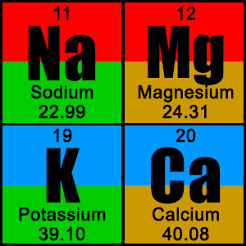The **periodic table** is organized like a big grid. Each **element** is placed in a specific location because of its atomic structure. As with any grid, the periodic table has rows (left to right) and columns (up and down). Each row and column has specific characteristics. For example, [magnesium](http://www.chem4kids.com/files/elements/012_speak.html) (Mg) and [calcium](http://www.chem4kids.com/files/elements/020_speak.html) (Mg) are found in column two and share certain similarities while [potassium](http://www.chem4kids.com/files/elements/019_speak.html) (K) and [calcium](http://www.chem4kids.com/files/elements/020_speak.html) (Ca) from row four share different characteristics. Magnesium and [sodium](http://www.chem4kids.com/files/elements/011_speak.html) (Na) also share qualities because the are in the same period (similar electron configurations).

# You've got Your Periods...

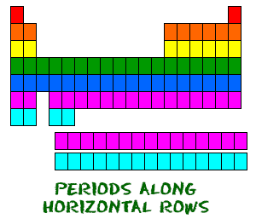Even though they skip some squares in between, all of the rows read left to right. When you look at the periodic table, each row is called a **period** (Get it? Like PERIODic table.). All of the elements in a period have the same number of [atomic orbitals](http://www.chem4kids.com/files/atom_orbital.html). For example, every element in the top row (the first period) has one orbital for its [electrons](http://www.chem4kids.com/files/atom_electron.html). All of the elements in the second row (the second period) have two orbitals for their electrons. As you move down the table, every row adds an orbital. At this time, there is a maximum of seven electron orbitals.

__

**43)**

# The Periodic Table: Families and Periods

In the [**periodic table of elements**](https://www.dummies.com/education/science/chemistry/periodic-table-of-elements-2/), there are seven horizontal rows of elements called *periods*. The vertical columns of elements are called groups, or *families*. (See also [**The Periodic Table: Metals, Nonmetals, and Metalloids**](https://www.dummies.com/education/science/chemistry/the-periodic-table-metals-nonmetals-and-metalloids/).)

## Periods in the periodic table

In each period (horizontal row), the atomic numbers increase from left to right. The periods are numbered 1 through 7 on the left-hand side of the table.

Elements that are in the same period have chemical properties that are not all that similar. Consider the first two members of period 3: sodium (Na) and magnesium (Mg). In reactions, they both tend to lose electrons (after all, they are metals), but sodium loses one electron, while magnesium loses two. Chlorine (Cl), down near the end of the period, tends to gain an electron (it’s a nonmetal).

ADVERTISING

## Families in the periodic table

Members of the families (vertical columns) in the periodic table have similar properties. The families are labeled at the top of the columns in one of two ways:

* The older method uses Roman numerals and letters. Many chemists prefer and still use this method.
* The newer method uses the numbers 1 through 18.

So why do the elements in the same family have similar properties? You can examine four families on the periodic table and look at the electron configurations for a few elements in each family.

The figure below lists some important families that are given special names:

* **The IA family is made up of the *alkali metals*.** In reactions, these elements all tend to lose a single electron. This family contains some important elements, such as sodium (Na) and potassium (K). Both of these elements play an important role in the chemistry of the body and are commonly found in salts.
* **The IIA family is made up of the *alkaline earth metals*.** All these elements tend to lose two electrons. Calcium (Ca) is an important member of the IIA family (you need calcium for healthy teeth and bones).
* **The VIIA family is made up of the *halogens*.** They all tend to gain a single electron in reactions. Important members in the family include chlorine (Cl), used in making table salt and bleach, and iodine (I).
* **The VIIIA family is made up of the *noble gases*.** These elements are very unreactive. For a long time, the noble gases were called the inert gases, because people thought that these elements wouldn’t react at all.

A scientist named Neil Bartlett showed that at least some of the inert gases could be reacted, but they required very special conditions. After Bartlett’s discovery, the gases were then referred to as noble gases.

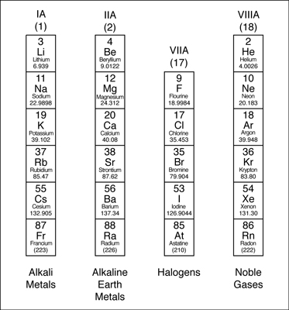

## Valence electrons and families

An *electron configuration* shows the number of electrons in each orbital in a particular atom. These electron configurations show that there are some similarities among each group of elements in terms of their valence electrons.

**44)**

# How To Find The Number Of Valence Electrons?

[Akash Peshin](https://www.scienceabc.com/author/akash)  2 Years Ago

**Valence electrons** are those electrons that reside in the outermost shell surrounding an atomic nucleus. Valence electrons are of crucial importance because they lend deep insight into an element’s chemical properties: whether it is electronegative or electropositive in nature, or they indicate the bond order of a chemical compound – the number of bonds that can be formed between two atoms. Since covalent bonds are formed by the sharing of electrons present in the final shell, the number indicates how many bonds are permitted to form.

The most palpable method would be to refer to an element’s atomic configuration and simply count the electrons in the outermost shell. However, this would be an extremely tedious chore, since we might have to rummage through textbooks to seek out configurations with which we’re not familiar.

__

**45)**

### The First Group

Sodium (Na) is an [element](https://www.ck12.org/c/chemistry/element) in group 1 of the periodic table of the elements. This group (column) of the table is shown in **Figure** [below](https://www.ck12.org/c/physical-science/hydrogen-and-alkali-metals/lesson/Hydrogen-and-Alkali-Metals-MS-PS/#x-ck12-TVMgUFMgMiAzIDcgR3JvdXAgMQ..). It includes the nonmetal hydrogen (H) and six [metals](https://www.ck12.org/c/chemistry/metals) that are called **alkali metals**. Elements in the same group of the periodic table have the same number of valence electrons. These are the electrons in their outer [energy level](https://www.ck12.org/c/chemistry/energy-level) that can be involved in chemical reactions. Valence electrons determine many of the properties of an [element](https://www.ck12.org/c/chemistry/element), so elements in the same group have similar properties. All the elements in group 1 have just one valence [electron](https://www.ck12.org/c/chemistry/electron). This makes them very reactive.

**Q:** Why does having just one valence [electron](https://www.ck12.org/c/chemistry/electron) make group 1 elements very reactive?

**A:** With just one valence [electron](https://www.ck12.org/c/chemistry/electron), group 1 elements are “eager” to lose that electron. Doing so allows them to achieve a full outer [energy level](https://www.ck12.org/c/chemistry/energy-level) and maximum stability.

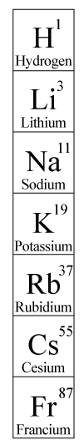

[Figure2]

### Reactivity of Group 1 Elements

Hydrogen is a very reactive [gas](https://www.ck12.org/c/physical-science/gas), and the alkali [metals](https://www.ck12.org/c/chemistry/metals) are even more reactive. In fact, they are the most reactive metals and, along with the elements in group 17, are the most reactive of all elements. The reactivity of alkali metals increases from the top to the bottom of the group, so lithium (Li) is the least reactive **alkali metal** and francium (Fr) is the most reactive. Because alkali metals are so reactive, they are found in nature only in combination with other elements. They often combine with group 17 elements, which are very “eager” to gain an electron.

__

**46)**

## Gases Are So Noble

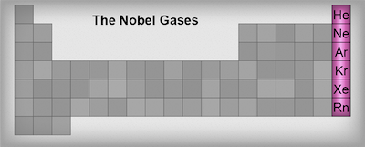  
The noble gases: group 8.  
  
There are six gaseous elements located in group 8A (or group 18) of the periodic table: helium (He), neon (Ne), argon (Ar), krypton (Kr), xenon (Xe), and radon (Rn). Collectively these gases are known as the noble gases. These gases are not heir to the throne nor are they superior in morals. The noble part of their name actually arises from the German word edelgas, which means unreactive.  
  
We've mentioned a gazillion times that other elements strive to achieve the stability of the noble gases, but where does this stability come from? Electrons. The valence electron configurations of these stable elements are: ns2np6, where n is the period in which the gas resides. Two completely filled orbitals means ultimate stability. [Yoda](http://www.youtube.com/watch?v=xUlqDMcS_RE) would be proud.  
  
Helium is slightly different than the other noble gas elements. It only has two electrons in its outer shell so its valence electron configuration is 1s2. Even though it only has two electrons, it is grouped with elements that have eight valence electrons. Helium is still happy because its outermost shell is completely full making it extremely stable.

Because of their uber-high stability, the noble gases are relatively unreactive. They have very high ionization energies and negligible electronegativities because they have no desire to gain or lose an electron.  
One noble gas that exhibits some degree of reactivity is Xenon (Xe, Z = 54). While most xenon is found as pure Xe, it can form complexes like XeF6, XeF4, XeO3, and XePtF6. Xenon was first called "the stranger" because it was the last noble gas to be isolated and characterized. It is an odorless, colorless gas, but when it is put in a vacuum tube and excited with electricity it glows blue.  
  
Xenon glows blue when put in a vacuum tube and electricized. See an example [here](https://ebid.nashville.gov/AuctionImages/35bbad0d-6a9b-4111-9b3c-f7bb0b62b26e.jpg).  
  
One group 18 element we're all familiar with is helium (He, Z = 2). Stores use helium to fill up their balloons because it is less dense than air, which means it rises without being pushed. What fun would a balloon be if it just laid on the floor?  
  
Helium is the second most abundant element in the universe and was discovered on the sun before it was found on Earth. Weird, we know. It, along with neon (Ne), is one of two elements that have never been observed to bond with another element in a compound. Talk about not playing well with others. That's what we like to call unreactive.  
  
Speaking of neon (Ne, Z = 10), it's another element that we are all quite familiar with. It's lightweight, colorless, and glows a reddish-orange in a vacuum tube. Those bright shiny signs we see on businesses everywhere are made possible by neon.  
  
Neon Signs Are Everywhere. See an example [here](http://www.propertiesofmatter.si.edu/images/L21/c13_Ne.jpg).

**47)**

**Step 2 - The Number of Protons is...**

The **atomic number** is the number of protons in an atom of an element. In our example, krypton's atomic number is 36. This tells us that an atom of krypton has 36 protons in its [nucleus](https://education.jlab.org/glossary/nucleus.html).

The interesting thing here is that **every** atom of krypton contains 36 protons. If an atom doesn't have 36 protons, it can't be an atom of krypton. Adding or removing protons from the nucleus of an atom creates a different element. For example, removing one proton from an atom of krypton creates an atom of [bromine](https://education.jlab.org/itselemental/ele035.html).

**Step 3 - The Number of Electrons is...**

By definition, atoms have no overall electrical charge. That means that there must be a balance between the positively charged protons and the negatively charged electrons. Atoms must have **equal numbers of protons and electrons**. In our example, an atom of krypton must contain 36 electrons since it contains 36 protons.

Electrons are arranged around atoms in a special way. If you need to know how the electrons are arranged around an atom, take a look at the '[How do I read an electron configuration table?](https://education.jlab.org/qa/electron_config.html)' page.

An atom can gain or lose electrons, becoming what is known as an **ion**. An ion is nothing more than an electrically charged atom. Adding or removing electrons from an atom does not change which element it is, just its net charge.

For example, removing an electron from an atom of krypton forms a krypton ion, which is usually written as Kr+. The plus sign means that this is a positively charged ion. It is positively charged because a negatively charged electron was removed from the atom. The 35 remaining electrons were outnumbered by the 36 positively charged protons, resulting in a charge of +1.

**Step 4 - The Number of Neutrons is...**

The **atomic weight** is basically a measurement of the **total number of particles in an atom's nucleus**. In reality, it isn't that clean cut. The atomic weight is actually a weighted average of all of the naturally occurring [isotopes](https://education.jlab.org/glossary/isotope.html) of an element relative to the mass of carbon-12. Didn't understand that? Doesn't matter. All you really need to find is something called the **mass number**. Unfortunately, the mass number isn't listed on the Table of Elements. Happily, to find the mass number, all you need to do is **round the atomic weight to the nearest whole number**. In our example, krypton's mass number is 84 since its atomic weight, 83.80, rounds up to 84.

The mass number is a count of the number of particles in an atom's nucleus. Remember that the [nucleus](https://education.jlab.org/atomtour/nucleus.html) is made up of protons and neutrons. So, if we want, we can write:

Mass Number = (Number of Protons) + (Number of Neutrons)

For krypton, this equation becomes:

84 = (Number of Protons) + (Number of Neutrons)

If we only knew how many protons krypton has, we could figure out how many neutrons it has. Wait a minute... We **do** know how many protons krypton has! We did that back in **Step 2**! The **atomic number** (36) is the number of protons in krypton. Putting this into the equation, we get:

84 = 36 + (Number of Neutrons)

What number added to 36 makes 84? Hopefully, you said 48. That is the number of neutrons in an atom of krypton.

The interesting thing here is that adding or removing neutrons from an atom does not create a different element. Rather, it creates a heavier or lighter version of that element. These different versions are called [isotopes](https://education.jlab.org/glossary/isotope.html) and most elements are actually a mixture of different isotopes.

If you could grab atoms of krypton and count the number of neutrons each one had, you would find that most would have 48, others would have 47, some would have 50, some others would have 46, a few would have 44 and a very few would have 42. You would count different numbers of neutrons because krypton is a mixture of six isotopes.

**In Summary...**

For any element:

Number of Protons = Atomic Number

Number of Electrons = Number of Protons = Atomic Number

Number of Neutrons = Mass Number - Atomic Number

For krypton:

Number of Protons = Atomic Number = 36

Number of Electrons = Number of Protons = Atomic Number = 36

Number of Neutrons = Mass Number - Atomic Number = 84 - 36 = 48

**48)**

**In Summary...**

For any element:

Number of Protons = Atomic Number

Number of Electrons = Number of Protons = Atomic Number

Number of Neutrons = Mass Number - Atomic Number

For krypton:

Number of Protons = Atomic Number = 36

Number of Electrons = Number of Protons = Atomic Number = 36

Number of Neutrons = Mass Number - Atomic Number = 84 - 36 = 48

The atomic mass equals the number of protons plus the number of neutrons, so you find the number of neutrons by subtracting the number of protons (i.e. the atomic number) from the atomic mass (in atomic mass units). Round the atomic mass to the nearest whole number to find the number of neutrons in the most common isotope.